a

|  |  |  |  |
| --- | --- | --- | --- |
| **TABLE OF CONTENTS** | | | |
|  |  | ***Title*** | ***Page No.*** |
|  | **TABLE OF CONTENTS** | | 04 |
| **1** | **INTRODUCTION** | |  |
|  | 1.1 Project Idea | | 12 |
|  | 1.2 | Overview | 13 |
|  | 1.3 | Modules | 14 |
| **2** | **SOFTWARE REQUIREMENT SPECIFICATION** | | |
|  | 2.1 Introduction | | 16 |
|  | 2.2 Functional Requirements | | 17 |
|  | 2.3 Non FunctionalRequirements | | 19 |
|  | 2.4 | Hardware Requirements | 22 |
|  | 2. 5 Software Requirements | | 22 |
| **3** | **ANALYSIS AND DESIGN PHASE** | |  |
|  | 3.1 Introduction | | 25 |
|  | 3.2 ClassDiagram | | 25 |
|  | 3.3 | Object Diagram | 26 |
|  | 3.4 | Activity Diagram | 27 |
|  | 3.5 | Sequence Diagram | 28 |
|  | 3.6Collaboration Diagram | | 29 |
|  | 3.7State chart Diagram | | 30 |
| 3.8 Component Diagram | | | 31 |
|  | 3.9Deployment Diagram | | 31 |
|  | 3.10 Data Design | | 32 |
|  | 3.11Conclusion | | 35 |

|  |  |
| --- | --- |
| **4 SYSTEM LOW LEVEL DESIGN** |  |
| 4.1 Modules of the project | 37 |
| 4.2 Objectives | 37 |
| 4.3 Project overview | 38 |
| **5IMPLEMENTATION** |  |
| 5.1 Same Code | 41 |
| 5.2 Screen Captures | 52 |
| 5.3 Firebase Analytics | 59 |
| **6TESTING** |  |
| 6.1 Software Testing | 63 |
| 6.2 Black Box Testing | 63 |
| 6.3White Box Testing | 63 |
| 6.4 Performance Testing | 63 |
| 6.5Load Testing | 63 |
| 6.6Manual Testing | 63 |
| 6.7Firebase Test Lab | 67 |
| **7 RESULTS AND CHALLENGES** |  |
| 7.1 Results | 70 |
| 7.2Challenges | 70 |
| **8 CONCLUSION AND FUTURE WORK** |  |
| 8.1 Conclusion | 72 |
| 8.2Scope for future work | 72 |
| 8.3Limitations | 72 |
| **BIBILOGRAPHY** | 73 |

## LIST OF FIGURES

|  |  |  |
| --- | --- | --- |
| **FIGURE NO** | **TITLE** | **PAGENO** |
| 2.1 | Use Case Diagram | 21 |
| 3.2 | Class Diagram | 25 |
| 3.3 | Object Diagram | 26 |
| 3.4 | Activity Diagram | 27 |
| 3.5 | Sequence diagram | 28 |
| 3.6 | Collaboration diagram | 29 |
| 3.7 | State Chart diagram | 30 |
| 3.8 | Component diagram | 30 |
| 3.9 | Deployment diagram | 31 |
| 5.2.1 | User login screen | 52 |
| 5.2.2 | Forgot password page | 52 |
| 5.2.3 | User sign up page | 53 |
| 5.2.4 | User home screen | 53 |
| 5.2.5 | Service page | 54 |
| 5.2.6 | Booking page | 54 |
| 5.2.7 | All bookings page | 55 |
| 5.2.8 | Referral page | 55 |
| 5.2.9 | User profile page | 56 |
| 5.2.10 | Service provider login page | 56 |
| 5.2.11 | Service provider signup page | 57 |
| 5.2.12 | Service provider bookings | 57 |
| 5.2.13 | Reference page | 58 |
| 5.2.14 | Service provider profile page | 58 |
| 5.3.1 | Firebase Authentication | 59 |
| 5.3.2 | Password reset mail template | 59 |
| 5.3.3 | Firebase Database | 60 |
| 5.3.4 | Active sessions | 60 |
| 5.3.5 | User engagement | 61 |

|  |  |  |
| --- | --- | --- |
| 6.1 | Test case for empty login | 64 |
| 6.2 | Test case for wrong login | 65 |
| 6.3 | Test case for signup fail | 66 |
| 6.4 | Test case for user signup fail | 67 |
| 6.7 | Firebase test lab clusters | 68 |

**LIST OF TABLES**

|  |  |  |
| --- | --- | --- |
| Table 3.10.1 | SQLite Database | 32 |
| Table 3.10.2 | List of tables in database | 32 |
| Table 3.10.3 | Admin table | 32 |
| Table 3.10.4 | Users table | 33 |
| Table 3.10.5 | Service providers table | 33 |
| Table 3.10.6 | Bookings table | 34 |
| Table 3.10.7 | Services table | 34 |
| Table 6:1 | Test case for empty login fields | 64 |
| Table 6:2 | Test case for wrong login fields | 64 |
| Table 6:3 | Test case for signup fail | 65 |
| Table 6:4 | Test case for User signup fail | 67 |

**ACRONYMS & ABBREVIATIONS**

|  |  |
| --- | --- |
| * **HTML:** | Hyper Text Markup Language. |
| * **XML:** | Extensible Markup Language. |
| * **IDE:** | Integrated Development Environment |
| * **PHP:** | Hyper Text Preprocessor |
| * **RDBMS:** | Relational Database Management System. |
| * **GUI:** | Graphical User Interface |
| * **HTTP:** | Hyper Text Transfer Protocol |
| * **API:** | Application Programming Interface |
| * **E-R:** | Entity-Relationship |
| * **UML:** | Unified Modeling Language |
| * **OOAD:** | Object-Oriented Analysis & Design. |

**INTERNSHIP SUMMARY**

**Location:**Hyderabad

**Center:** “Name of the organization”

**Duration:**

**Date of start:**

**Date of submission:**

**Title of project:**

**Team Members:**

xxxxxx(151FA0xxxx) xxxxxx(151FA0xxxx) **Name of the guide:**

**Name ofFacultyguide:** VFSTR University. **Project Area: Use of Artificial**

**Abstract:**

* we use machine learning, namely an artificial neural network to determine what are the chances that Facebook friend request is authentic or not. We also outline the classes and libraries involved. Furthermore, we discuss the sigmoid function and how the weights are determined and used. Finally, we consider the parameters of the social network page which are utmost important in the provided solution.
* The other dangers of personal data being obtained for fraudulent purposes is the presence of bots and fake profiles. Bots are programs that can gather information about the user without the user even knowing. This process is known as web scraping. What is worse, is that this action is legal. Bots can be hidden or come in the form of a fake friend request on a social network site to gain access to private information.

**Signatureof Student Signature of FacultyGuide**

**Date: Date:**

# PROFILE OF THE COMPANY

**About ECIL**

**Electronics Corporation of India Limited (ECIL)** is a Government of India Enterprise under the Department of Atomic Energy, established on April 11, 1967 by A. S. Rao at Hyderabad, to create a strong indigenous base in electronics. ECIL is a multi-product, multi- disciplinaryorganization with focus on indigenous Nuclear energy, space and Defense sectors. ECIL also has a strong presence in indigenous Electronic Security, Communications, Networking and e-governance domains. ECIL has committed partnerships with nuclear energy establishments of India, particularly Bhabha Atomic Research Center (BARC), Nuclear Power Corporation of India Limited (NPCIL) and Indira Gandhi Centre for Atomic Research (IGCAR). ECIL also actively supports other strategic sectors such as indigenous Defense (Defense Research and Development Organization(DRDO)), Space (Department of Space (India))Civil Aviation, Information and Broadcasting, Telecommunications, Insurance, Banking, Police and Para-military Forces, Oil and Gas, Power, Space Education, Health, Agriculture, Steel and Coal. ECIL is credited with producing the first indigenous digital computers, TDC 312 and TDC 316, solid state TV, control and instrumentation for nuclear power plants and first earth station antenna of India.

**Company address:**

A.S. Rao Nagar, ECIL, Hyderabad

***CHAPTER -1***

***INTRODUCTION***

*The chapter gives brief introduction of theproject.*

## CHAPTER 1 INTRODUCTION

* In 2017 Facebook reached a total population of 2.46 billion users making it the most popular choice of social media [1]. Social media networks make revenues from the data provided by users. The average user does not know that their rights are given up the moment they use the social media network's service. Social media companies have a lot to gain at the expense of the user. Every time a user shares a new location, new photos, likes, dislikes, and tag other users in content posted, Facebook makes revenue via advertisements and data. More specifically, the average American user generates about $26.76 per quarter [2]. That number adds up quickly when millions of users are involved.
* In today's digital age, the ever-increasing dependency on computer technology has left the average citizen vulnerable to crimes such as data breaches and possible identity theft.
* These attacks can occur without notice and often without notification to the victims of a data breach. At this time, there is little incentive for social networks to improve their data security.
* These breaches often target social media networks such as Facebook and Twitter. They can also target banks and other financial institutions.

***CHAPTER -2***

***SOFTWAREREQUIREMENT***

***SPECIFICATION***

*Gives the details of platform specifications, Hardware,and Softwarespecifications.*

## CHAPTER 2 REQUIREMENT ANALYSIS

This chapter provides the details of the project’s need based survey, system requirements, Hardware Requirements, Software Requirements, and System Requirements.

**Project Overview :-**

* Each input neuron would be a different, previously chosen feature of each profile converted into a numerical value (e.g., gender as a binary number, female 0 and male 1) and if needed, divided by an arbitrary number (e.g., age is always divided by 100) to minimize one feature having more influence on the result than the other. The neurons represent nodes. Each node would be responsible for exactly one decision-making process

**Existing System :-**

* Malicious users create fake profiles to phish login information from unsuspecting users. A fake profile will send friend requests to many users with public profiles. These counterfeit profiles bait unsuspecting users with pictures of people that are considered attractive. Once the user accepts the request, the owner of the phony profile will spam friend requests to anyone this user is a friend.
* The fake profile's contents typically have links that lead to an external website where the damage happens. An unaware curious user clicking the bad link will damage their computer. The cost can be as simple as catching a virus to as bad as installing a rootkit turning the computer into a zombie. While Facebook has a rigorous screening to keep these fake accounts out, it only takes one fake profile to damage the computers of many.

**Proposed System :-**

* In our solution, we use machine learning, namely an artificial neural network to determine what are the chances that a friend request is authentic or not.
* We utilize Microsoft Excel to store old and new fake data profiles. The algorithm then stores the data in a data frame. This collection of data will be divided into a training set and a testing set. We would need a data set from the social media sites to train our model.
* For the training set, the features that we use to determine a fake profile are Account age, Gender, User age, Link in the description, Number of messages sent out, Number of friend requests sent out, Entered location, Location by IP, Fake or Not. Each of these parameters is tested and assigned a value. For example, for the gender parameter if the profile can be determined to be a female or male a value of (1) is assigned to the training set for Gender. The same process is applied to other parameters. We also use the country of origin as a factor

**Advantages :-**

* Vote Trust uses a voting based system that pulls user activities to find fake profiles using trust-based vote assignment and global votes total. It is considered as the first line of defense due to limitations which include real accounts that were already compromised being sold

**Functional requirements :-**

In software engineering, a functional requirement defines a system or its component. It describes the functions a software must perform. A function is nothing but inputs, its behavior, and outputs. It can be a calculation, data manipulation, business process, user interaction, or any other specific functionality which defines what function a system is likely to perform.

Functional software requirements help you to capture the intended behavior of the system. This behavior may be expressed as functions, services or tasks or which system is required to perform.

**Non –Functional Requirements :-**

A non-functional requirement defines the quality attribute of a software system. They represent a set of standards used to judge the specific operation of a system. Example, how fast does the website load?

A non-functional requirement is essential to ensure the usability and effectiveness of the entire software system. Failing to meet non-functional requirements can result in systems that fail to satisfy user needs.

**Hardware Requirements :-**

* Operating System supported by

1. Windows 7

2. Windows XP

3 . Windows 8

* Processor – Pentium IV or higher
* RAM -- 256 MB
* Space on Hard Disk -- Minimum 512 MB

**Software Requirements :-**

* For developing the Application

1. Python

2. Django

3. Mysql

4. Mysqlclient

5. WampServer 2.4

* Technologies and Languages used to Develop

-- Python

### HOME PAGE:-

* XML
* JAVA

### REGISTRATIONPAGE:-

* XML
* JAVA

### LOGINPAGE:-

* XML
* JAVA

### BOOKINGS PAGE

* XML
* JAVA

### REFERRALSPAGE

* XML
* JAVA

### PROFILEPAGE

* XML
* JAVA

### PREFERENCEPAGE

* XML
* JAVA

### SP LOGINPAGE

* XML
* JAVA

### SP SIGN UPPAGE

* XML
* JAVA

### SP BOOKINGPAGE

* XML
* JAVA

***CHAPTER -3***

***ANALYSIS &DESIGN***

*This chapter gives the details of the system and data design.*

### CHAPTER 3 DESIGN PHASE

**INTRODUCTION**

This chapter provides the design phase of the Application. To design the project, we use the UML diagrams. The Unified Modelling Language (UML) is a general- purpose, developmental, modelling language in the field of software engineering that is intended to provide a standard way to visualize the design of a system.

### 3.1 USE CASE DIAGRAM

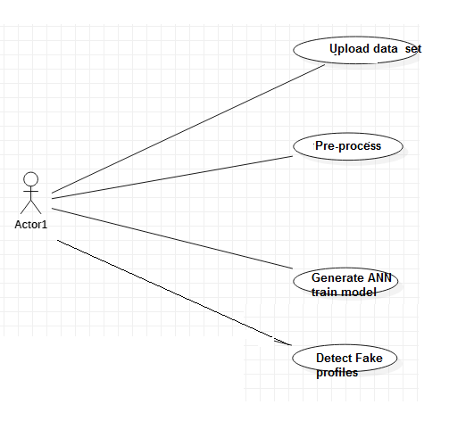

**Fig 2.1 Use case Diagram**

The use case diagram is used to represent all the functional use cases that are involved in the project.

The above diagram represents the main two **actors** in the project, they are

* + - User

### CLASSDIAGRAM

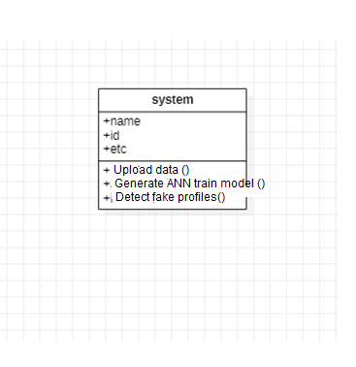

**Fig 3.2 class diagram**

The above mentioned class diagram represents the Chatbot system workflow model. This diagram has class models with class names as

* + - User
    - Admin
    - Homescreen

### SEQUENCEDIAGRAM

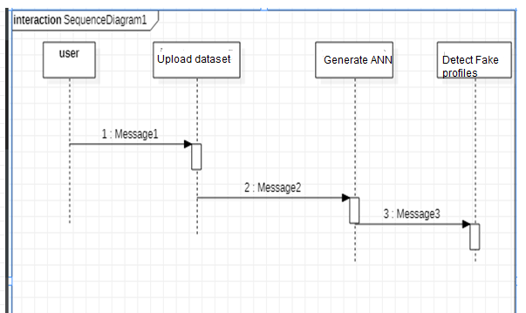

**Fig 3.5 sequence diagram**

The above diagram represents the sequence of flow of actions in the system.

### Activity DIAGRAM

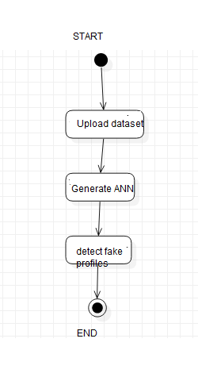

## DATADESIGN

* + 1. **DatabasesSQLite**

|  |
| --- |
| **Name** |
| Use of Artificial |

**Table 3.10.1 SQLite Database**

* + 1. **Tables**

|  |  |
| --- | --- |
| **Name** | **Description** |
| Users | Contains all the registered user details. |
| View Fake profiles dedection | All the registered service provider details. |
| Services | Contains all the types of services available. |

**Table 3.10.2 List of Database Tables**

## CONCLUSION

* we use machine learning, namely an artificial neural network to determine what are the chances that a friend request is authentic are or not. Each equation at each neuron (node) is put through a Sigmoid function. We use a training data set by Facebook or other social networks. This would allow the presented deep learning algorithm to learn the patterns of bot behavior by back propagation, minimizing the final cost function and adjusting each neuron's weight and bias.
* In this paper, we outline the classes and libraries involved. We also discuss the sigmoid function and how are the weights determined and used. We also consider the parameters of the social network page which are the most important to our solution.

***CHAPTER -4***

***SYSTEM LOWLEVELDESIGN***

*This chapter gives an overview of all modules in theproject.*

### CHAPTER 4

**SYSTEM LOWLEVEL DESIGN**

This chapter mainly provides the overview on modules of the application, objectivesof the project and a detailed projectoverview.

* 1. **Modules of theApplication:**

**Admin Module:** Admin will login to application by using username as ‘admin’ and password as ‘admin’ and then perform below actions.

1. **Generate ANN Train Model:** Admin will upload profile dataset to ANN algorithm to build train model. This train model can be used to predict fake or genuine account by taking new account test data.
2. **View ANN Train Dataset:** Using this module admin can view all dataset used to train ANN model.

User Module: Any user can use this application and enter test data of new account and call ANN algorithm. ANN algorithm will take new test data and applied train model to predict whether given test data contains fake or genuine details.

* 1. **OBJECTIVES OF THEPROJECT**

# In this paper, we outline the classes and libraries involved. We also discuss the sigmoid function and how are the weights determined and used. We also consider the parameters of the social network page which are the most important to our solution.

***CHAPTER -5***

***IMPLEMENTATION***

*The chapter gives the details of theimplementation.*

### CHAPTER 5 IMPLEMENTATION

This chapter mainly provides the sample code and implementation of the project.

* 1. **SampleCode**
     1. **XML Code for Bookingspage**

*<?***xml version="1.0" encoding="utf-8"***?>*

<**LinearLayoutxmlns:android="**[**http://schemas.android.com/apk/res/android**](http://schemas.android.com/apk/res/android)**" android:layout_width="match_parent" android:layout_height="match_parent"**

**android:orientation="vertical"**>

<**android.support.v7.widget.LinearLayoutCompat android:layout_width="match_parent" android:layout_height="150dp" android:background="@color/colorTextHint" android:gravity="center" android:orientation="vertical"**>

<**android.support.v7.widget.AppCompatTextView android:layout_width="wrap_content" android:layout_height="wrap_content" android:text="Bookings" android:textSize="20sp"** />

<**android.support.v7.widget.AppCompatTextView android:layout_width="wrap_content" android:layout_height="wrap_content" android:layout_marginTop="10dp" android:text="@string/text_hello"** />

<**android.support.v7.widget.AppCompatTextView android:id="@+id/textViewName" android:layout_width="wrap_content" android:layout_height="wrap_content"** />

</**android.support.v7.widget.LinearLayoutCompat**>

<**android.support.v7.widget.AppCompatTextView android:layout_width="wrap_content" android:layout_height="wrap_content" android:paddingBottom="5dp" android:paddingLeft="16dp" android:paddingTop="5dp" android:text="Bookings" android:textColor="@android:color/black"** />

<**ScrollView android:id="@+id/scrollview" android:layout_width="fill_parent" android:layout_height="fill_parent" android:layout_below="@+id/spinner1" android:layout_alignParentBottom="true" android:layout_alignParentLeft="true"**>

<**LinearLayout android:layout_width="match_parent" android:layout_height="562dp" android:layout_marginBottom="200dp" android:orientation="vertical"** >

<**ListView**

**android:id="@+id/listView1" android:layout_width="wrap_content" android:layout_height="600dp" android:layout_marginLeft="0dp"** >

</**ListView**>

</**LinearLayout**>

</**ScrollView**>

</**LinearLayout**>

* + 1. **Java Code for Bookingspage**

**package** com.example.spaceimpactor.houser.activities;

**import** java.util.ArrayList; **import** android.os.Bundle; **import** android.app.Activity; **import** android.content.Context; **import** android.content.Intent; **import**android.database.Cursor;

**import** android.database.sqlite.SQLiteDatabase;

**import** android.view.View;

**import** android.view.View.OnClickListener; **import** android.widget.AdapterView; **import** android.widget.ArrayAdapter; **import** android.widget.Button;

**import** android.widget.EditText; **import** android.widget.ImageView; **import** android.widget.ListView; **import** android.widget.Spinner; **import** android.widget.TextView;

**import** android.widget.AdapterView.OnItemClickListener;

**import** android.widget.Toast;

**import** com.example.spaceimpactor.houser.R;

**public class** Bookings **extends** Activity{ Spinner **sp**;

ImageView**out**; TextView**aaa**; SQLiteDatabase**db**; ListView**l**; EditText**t1**;

ArrayList<String>**list1**; ArrayAdapter**adapter**;

Button **sub**;

String **lmb**,**lser**,**lem**;

@Override

**protected void** onCreate(Bundle savedInstanceState) { **super**.onCreate(savedInstanceState); setContentView(R.layout.***activity_bookings***);

**final** GlobalClassglobalvariabel=(GlobalClass)getApplicationContext(); **aaa**=(TextView)findViewById(R.id.***textViewName***); **aaa**.setText(globalvariabel.GetUsername().toString());

**db**=openOrCreateDatabase(**"ServiceProvider"**, Context.***MODE_PRIVATE***, **null**); **l** = (ListView) findViewById(R.id.***listView1***);

**final** ArrayList<String> list = **new** ArrayList<String>();

**list1** = **new** ArrayList<String>();

Cursor res = **db**.rawQuery(**"SELECT * FROM book where uid='"** + **aaa**.getText() + **"'"**, **null**); **if** (res.getCount() != 0) {

**while** (res.moveToNext()) {

list.add(**"Name: "** + res.getString(1) + **"\nMobile No: "** + res.getString(2) + **"\n"** + **"Service Type: "** + res.getString(3) + **"\n"** + **"Email: "** + res.getString(4)+ **"\n"** + **"Booking Date: "** + res.getString(5));

**list1**.add(res.getString(1));

}

}

**adapter** = **new** ArrayAdapter<String>(**this**, android.R.layout.***simple_list_item_1***, list);

**l**.setAdapter(**adapter**);

}

}

* + 1. **Java Code for ProfileFragment**

**package** com.example.spaceimpactor.houser.fragment;

**import** android.content.Context;

**import** android.content.Intent;

**import** android.database.sqlite.SQLiteDatabase;

**import** android.os.Bundle;

**import** android.support.annotation.NonNull; **import** android.support.v4.app.Fragment; **import** android.text.TextUtils;

**import** android.util.Log;

**import** android.view.LayoutInflater;

**import** android.view.View;

**import** android.view.ViewGroup;

**import** android.support.annotation.Nullable;

**import** android.support.design.widget.Snackbar;

**import** android.support.design.widget.TextInputEditText; **import** android.support.design.widget.TextInputLayout; **import** android.support.v4.widget.NestedScrollView; **import** android.support.v7.app.AppCompatActivity; **import** android.support.v7.widget.AppCompatButton; **import** android.support.v7.widget.AppCompatTextView; **import** android.widget.Button;

**import** android.widget.EditText; **import** android.widget.ProgressBar; **import** android.widget.TextView; **import** android.widget.Toast;

**import** com.google.firebase.auth.FirebaseAuth; **import** com.google.firebase.auth.FirebaseUser; **import** com.google.firebase.database.DataSnapshot; **import** com.google.firebase.database.DatabaseError;

**import** com.google.firebase.database.DatabaseReference; **import** com.google.firebase.database.FirebaseDatabase; **import** com.google.firebase.database.ValueEventListener;

**public class** ProfileFragment**extends** Fragment **implements** View.OnClickListener {

**private** NestedScrollView**nestedScrollView**;

**private** TextInputLayout**textInputLayoutName**; **private** TextInputLayout**textInputLayoutPhone**; **private** TextInputLayout**textInputLayoutEmail**; **private** TextInputLayout**textInputLayoutPassword**;

**private** TextInputLayout**textInputLayoutConfirmPassword**;

**private** TextInputEditText**textInputEditTextName**; **private** TextInputEditText**textInputEditTextPhone**; **private** TextInputEditText**textInputEditTextEmail**; **private** TextInputEditText**textInputEditTextPassword**;

**private** TextInputEditText**textInputEditTextConfirmPassword**;

**private** AppCompatButton**appCompatButtonRegister**;

**private** InputValidation**inputValidation**; **private** DatabaseHelper**databaseHelper**; **private** User **user**;

EditText**id**,**ps**,**em**,**mb**; Button **sub**;

SQLiteDatabase**db**; TextView**aaa**;

**private static final** String ***TAG*** = MainActivity.**class**.getSimpleName();

**private** TextView**txtDetails**;

**private** EditText**inputName**, **inputEmail**; **private** Button **btnSave**;

**private** DatabaseReference**mFirebaseDatabase**;

**private** FirebaseDatabase**mFirebaseInstance**;

**private** String **userId**;

**private** Button **btnChangeEmail**, **btnChangePassword**, **btnSendResetEmail**, **btnRemoveUser**, **changeEmail**, **changePassword**, **sendEmail**, **remove**, **signOut**;

**private** EditText**oldEmail**, **newEmail**, **password**, **newPassword**; **private** ProgressBar**progressBar**;

**private** FirebaseAuth.AuthStateListener**authListener**;

**private** FirebaseAuth**auth**;

@Override

**public** View onCreateView(LayoutInflaterinflater, ViewGroup container, Bundle savedInstanceState) {

*// Inflate the layout for this fragment*

View myView = inflater.inflate(R.layout.***fragment_profile***, container, **false**);

*// appCompatButtonRegister = (AppCompatButton)myView.findViewById(R.id.appCompatButtonRegister);*

*// appCompatButtonRegister.setOnClickListener(this);*

**return** myView;

}

**private void** createUser(String name, String email) {

*//* ***TODO***

*// In real apps this userId should be fetched*

*// by implementing firebase auth*

**if** (TextUtils.*isEmpty*(**userId**)) {

**userId**= **mFirebaseDatabase**.push().getKey();

}

User user = **new** User();

**mFirebaseDatabase**.child(**userId**).setValue(user); addUserChangeListener();

}

*/\*\**

* *User data changelistener*

*\*/*

**private void** addUserChangeListener() {

*// User data change listener* **mFirebaseDatabase**.child(**userId**).addValueEventListener(**new** ValueEventListener() { @Override

**public void** onDataChange(DataSnapshotdataSnapshot) { User user = dataSnapshot.getValue(User.**class**);

*// Check for null*

**if** (user == **null**) {

Log.*e*(***TAG***, **"User data is null!"**); **return**;

}

**inputEmail**.setText(**""**); **inputName**.setText(**""**);

}

@Override

**public void** onCancelled(DatabaseError error) {

*// Failed to read value*

Log.*e*(***TAG***, **"Failed to read user"**, error.toException());

}

});

}

**private void** updateUser(String name, String email) {

*// updating the user via child nodes*

**if** (!TextUtils.*isEmpty*(name))

**mFirebaseDatabase**.child(**userId**).child(**"name"**).setValue(name);

**if** (!TextUtils.*isEmpty*(email))

**mFirebaseDatabase**.child(**userId**).child(**"email"**).setValue(email);

}

*//sign out method* **public void** signOut() { **auth**.signOut();

}

@Override

**public void** onResume() { **super**.onResume(); **progressBar**.setVisibility(View.***GONE***);

}

@Override

**public void** onStart() {

**super**.onStart(); **auth**.addAuthStateListener(**authListener**);

}

@Override

**public void** onStop() {

**super**.onStop();

**if** (**authListener**!= **null**) {

**auth**.removeAuthStateListener(**authListener**);

}

}

**public void** onViewCreated(@NonNullView view, @NullableBundle savedInstanceState) {

**super**.onViewCreated(view, savedInstanceState);

*// initViews();*

*// initObjects();*

**auth**= FirebaseAuth.*getInstance*();

*//get current user*

**final** FirebaseUser user = FirebaseAuth.*getInstance*().getCurrentUser();

**authListener**= **new** FirebaseAuth.AuthStateListener() { @Override

**public void** onAuthStateChanged(@NonNullFirebaseAuthfirebaseAuth) { FirebaseUser user = firebaseAuth.getCurrentUser();

**if** (user == **null**) {

*// user auth state is changed - user is null*

*// launch login activity*

startActivity(**new** Intent(getActivity(), LoginActivity.**class**));

}

}

};

*// btnChangeEmail = (Button)findViewById(R.id.change_email_button);*

*//btnChangePassword = (Button) findViewById(R.id.change_password_button);* **btnSendResetEmail**= (Button) getView().findViewById(R.id.***sending_pass_reset_button***); **btnRemoveUser**= (Button) getView().findViewById(R.id.***remove_user_button***);

*// changeEmail = (Button)getView().findViewById(R.id.changeEmail);*

*// changePassword = (Button)getView().findViewById(R.id.changePass);*

**sendEmail**= (Button) getView().findViewById(R.id.***send***); **remove** = (Button) getView().findViewById(R.id.***remove***); **signOut**= (Button) getView().findViewById(R.id.***sign_out***);

**oldEmail**= (EditText) getView().findViewById(R.id.***old_email***); **newEmail**= (EditText) getView().findViewById(R.id.***new_email***); **password** = (EditText) getView().findViewById(R.id.***password***); **newPassword**= (EditText) getView().findViewById(R.id.***newPassword***);

**oldEmail**.setVisibility(View.***GONE***); **newEmail**.setVisibility(View.***GONE***); **password**.setVisibility(View.***GONE***); **newPassword**.setVisibility(View.***GONE***);

*// changeEmail.setVisibility(View.GONE);*

*// changePassword.setVisibility(View.GONE);* **sendEmail**.setVisibility(View.***GONE***); **remove**.setVisibility(View.***GONE***);

**progressBar**= (ProgressBar) getView().findViewById(R.id.***progressBar***);

**if** (**progressBar**!= **null**) {

**progressBar**.setVisibility(View.***GONE***);

}

**btnSendResetEmail**.setOnClickListener(**new** View.OnClickListener() { @Override

**public void** onClick(View v) { **oldEmail**.setVisibility(View.***VISIBLE***); **newEmail**.setVisibility(View.***GONE***); **password**.setVisibility(View.***GONE***); **newPassword**.setVisibility(View.***GONE***);

*// changeEmail.setVisibility(View.GONE);*

*// changePassword.setVisibility(View.GONE);* **sendEmail**.setVisibility(View.***VISIBLE***); **remove**.setVisibility(View.***GONE***);

}

});

**sendEmail**.setOnClickListener(**new** View.OnClickListener() { @Override

**public void** onClick(View v) {

**progressBar**.setVisibility(View.***VISIBLE***);

**if** (!**oldEmail**.getText().toString().trim().equals(**""**)) {

**auth**.sendPasswordResetEmail(**oldEmail**.getText().toString().trim())

.addOnCompleteListener(**new** OnCompleteListener<Void>() {

@Override

**public void** onComplete(@NonNullTask<Void> task) {

**if** (task.isSuccessful()) {

Toast.*makeText*(getActivity(), **"Reset password email is sent!"**, Toast.***LENGTH_SHORT***).show();

**progressBar**.setVisibility(View.***GONE***);

} **else** {

Toast.*makeText*(getActivity(), **"Failed to send reset email!"**, Toast.***LENGTH_SHORT***).show();

**progressBar**.setVisibility(View.***GONE***);

}

}

});

} **else** {

**oldEmail**.setError(**"Enter email"**); **progressBar**.setVisibility(View.***GONE***);

}

}

});

**btnRemoveUser**.setOnClickListener(**new** View.OnClickListener() { @Override

**public void** onClick(View v) {

**progressBar**.setVisibility(View.***VISIBLE***);

**if** (user != **null**) { user.delete()

@Override

.addOnCompleteListener(**new** OnCompleteListener<Void>() {

**public void** onComplete(@NonNullTask<Void> task) {

**if** (task.isSuccessful()) {

Toast.*makeText*(getActivity(), **"Your profile is deleted:( Create a account now!"**, Toast.***LENGTH_SHORT***).show(); startActivity(**new** Intent(getActivity(), RegisterActivity.**class**));

*// finish();*

**progressBar**.setVisibility(View.***GONE***);

} **else** {

Toast.*makeText*(getActivity(), **"Failed to delete your account!"**, Toast.***LENGTH_SHORT***).show();

**progressBar**.setVisibility(View.***GONE***);

}

}

});

}

}

});

**signOut**.setOnClickListener(**new** View.OnClickListener() { @Override

**public void** onClick(View v) { signOut();

}

});

*//txtDetails = (TextView) findViewById(R.id.txt_user);* **inputName**= (EditText) getView().findViewById(R.id.***name***); **inputEmail**= (EditText) getView().findViewById(R.id.***email***); **btnSave**= (Button) getView().findViewById(R.id.***btn_save***);

**mFirebaseInstance**= FirebaseDatabase.*getInstance*();

*// get reference to 'users' node*

**mFirebaseDatabase**= **mFirebaseInstance**.getReference(**"users"**);

*// store app title to 'app_title' node*

**mFirebaseInstance**.getReference(**"app_title"**).setValue(**"Houser"**);

*// app_title change listener* **mFirebaseInstance**.getReference(**"app_title"**).addValueEventListener(**new** ValueEventListener() { @Override

**public void** onDataChange(DataSnapshotdataSnapshot) { Log.*e*(***TAG***, **"App title updated"**);

String appTitle = dataSnapshot.getValue(String.**class**);

*// update toolbar title*

*//getSupportActionBar().setTitle(appTitle);*

}

@Override

**public void** onCancelled(DatabaseError error) {

*// Failed to read value*

Log.*e*(***TAG***, **"Failed to read app title value."**, error.toException());

}

});

*// Save / update the user* **btnSave**.setOnClickListener(**new** View.OnClickListener() { @Override

**public void** onClick(View view) {

String name = **inputName**.getText().toString(); String email = **inputEmail**.getText().toString();

*// Check for already existed userId* **if** (TextUtils.*isEmpty*(**userId**)) { createUser(name, email);

} **else** {

updateUser(name, email);

}

}

});

}

@Override

**public void** onClick(View v) { postDataToSQLite();

}

**private void** initViews() {

**nestedScrollView**= (NestedScrollView) getView().findViewById(R.id.***nestedScrollView***);

**textInputLayoutName**= (TextInputLayout) getView().findViewById(R.id.***textInputLayoutName***); **textInputLayoutPhone**= (TextInputLayout) getView().findViewById(R.id.***textInputLayoutPhone***); **textInputLayoutEmail**= (TextInputLayout) getView().findViewById(R.id.***textInputLayoutEmail***); **textInputLayoutPassword**= (TextInputLayout) getView().findViewById(R.id.***textInputLayoutPassword***); **textInputLayoutConfirmPassword**= (TextInputLayout) getView().findViewById(R.id.***textInputLayoutConfirmPassword***);

**textInputEditTextName**= (TextInputEditText) getView().findViewById(R.id.***textInputEditTextName***); **textInputEditTextPhone**= (TextInputEditText) getView().findViewById(R.id.***textInputEditTextPhone***); **textInputEditTextEmail**= (TextInputEditText) getView().findViewById(R.id.***textInputEditTextEmail***); **textInputEditTextPassword**= (TextInputEditText) getView().findViewById(R.id.***textInputEditTextPassword***); **textInputEditTextConfirmPassword**= (TextInputEditText) getView().findViewById(R.id.***textInputEditTextConfirmPassword***);

}

**private void** initObjects() {

**inputValidation**= **new** InputValidation(getActivity()); **databaseHelper**= **new** DatabaseHelper(getActivity()); **user** = **new** User();

}

**private void** postDataToSQLite() {

**if** (!**inputValidation**.isInputEditTextFilled(**textInputEditTextName**, **textInputLayoutName**, getString(R.string.***error_message_name***))) {

**return**;

}

**if** (!**inputValidation**.isInputEditTextFilled(**textInputEditTextPhone**, **textInputLayoutPhone**, **"Enter Phone Number"**)) {

**return**;

}

**if** (!**inputValidation**.isInputEditTextFilled(**textInputEditTextEmail**, **textInputLayoutEmail**, getString(R.string.***error_message_email***))) {

**return**;

}

**if** (!**inputValidation**.isInputEditTextFilled(**textInputEditTextEmail**, **textInputLayoutEmail**, getString(R.string.***error_message_email***))) {

**return**;

}

**if** (!**inputValidation**.isInputEditTextEmail(**textInputEditTextEmail**, **textInputLayoutEmail**, getString(R.string.***error_message_email***))) {

**return**;

}

**if** (!**inputValidation**.isInputEditTextPhone(**textInputEditTextPhone**, **textInputLayoutPhone**, getString(R.string.***error_message_phone***))) {

**return**;

}

**if** (!**inputValidation**.isInputEditTextFilled(**textInputEditTextPassword**, **textInputLayoutPassword**,

getString(R.string.***error_message_password***))) {

**return**;

}

**if** (!**inputValidation**.isInputEditTextMatches(**textInputEditTextPassword**, **textInputEditTextConfirmPassword**, **textInputLayoutConfirmPassword**, getString(R.string.***error_password_match***))) {

**return**;

}

**if** (!**databaseHelper**.checkUser(**textInputEditTextEmail**.getText().toString().trim())) {

**user**.setName(**textInputEditTextName**.getText().toString().trim()); **user**.setPhone(**textInputEditTextPhone**.getText().toString().trim()); **user**.setEmail(**textInputEditTextEmail**.getText().toString().trim()); **user**.setPassword(**textInputEditTextPassword**.getText().toString().trim());

**databaseHelper**.updateUser(**user**); emptyInputEditText();

}

}

**private void** emptyInputEditText()

{

**textInputEditTextName**.setText(**null**); **textInputEditTextPhone**.setText(**null**); **textInputEditTextEmail**.setText(**null**); **textInputEditTextPassword**.setText(**null**); **textInputEditTextConfirmPassword**.setText(**null**);

}

}

**5.1.3 XML Code for Profile Fragment**

*<?***xml version="1.0" encoding="utf-8"***?>*

<**android.support.v4.widget.NestedScrollView xmlns:android="**[**http://schemas.android.com/apk/res/android**](http://schemas.android.com/apk/res/android)**" xmlns:tools="**[**http://schemas.android.com/tools**](http://schemas.android.com/tools)**"**

**xmlns:app="**[**http://schemas.android.com/apk/res-auto**](http://schemas.android.com/apk/res-auto)**" android:id="@+id/nestedScrollView" android:layout_width="match_parent" android:layout_height="match_parent" android:paddingBottom="20dp" android:paddingLeft="20dp" android:paddingRight="20dp" android:paddingTop="20dp"**>

<**LinearLayout android:layout_width="match_parent" android:layout_height="wrap_content" android:orientation="vertical"**

**android:paddingBottom="@dimen/activity_vertical_margin" android:paddingLeft="@dimen/activity_horizontal_margin" android:paddingRight="@dimen/activity_horizontal_margin" android:paddingTop="0dp" app:layout_behavior="@string/appbar_scrolling_view_behavior"**>

<**TextView android:layout_width="match_parent" android:layout_height="match_parent"**

**android:text="Update your Profile" android:textColor="@android:color/black" android:textStyle="bold" android:textSize="30sp" android:layout_marginBottom="70dp" android:gravity="center"**/>

<**EditText android:id="@+id/old_email" android:layout_width="match_parent" android:layout_height="wrap_content" android:hint="ConfirmEmail"**

**android:inputType="textEmailAddress" android:maxLines="1" android:singleLine="true"**/>

<**EditText android:id="@+id/new_email" android:layout_width="match_parent" android:layout_height="wrap_content" android:hint="New Email" android:inputType="textEmailAddress" android:maxLines="1" android:singleLine="true"**/>

<**EditText android:id="@+id/password" android:layout_width="match_parent" android:layout_height="wrap_content" android:focusableInTouchMode="true" android:hint="@string/hint_password" android:imeActionId="@+id/login"**

**android:imeOptions="actionUnspecified" android:inputType="textPassword" android:maxLines="1" android:singleLine="true" tools:ignore="InvalidImeActionId"**/>

<**EditText android:id="@+id/newPassword" android:layout_width="match_parent" android:layout_height="wrap_content" android:focusableInTouchMode="true" android:hint="New Password" android:imeActionId="@+id/login" android:imeOptions="actionUnspecified" android:inputType="textPassword" android:maxLines="1" android:singleLine="true" tools:ignore="InvalidImeActionId"**/>

<**Button android:id="@+id/send"**

**style="?android:textAppearanceSmall" android:layout_width="wrap_content" android:layout_height="wrap_content" android:layout_marginTop="16dp" android:background="@android:color/black" android:text="Send" android:textColor="@android:color/white" android:textStyle="bold" android:layout_gravity="end"**/>

<**ProgressBar android:id="@+id/progressBar" android:layout_width="30dp" android:layout_height="30dp" android:visibility="gone"** />

<**Button android:id="@+id/remove"**

**style="?android:textAppearanceSmall" android:layout_width="wrap_content" android:layout_height="wrap_content" android:layout_marginTop="16dp" android:background="@color/colorPrimaryDark" android:text="Remove" android:textColor="@android:color/white" android:textStyle="bold"** />

<**android.support.design.widget.TextInputLayout android:layout_width="match_parent" android:layout_height="wrap_content"**>

<**EditText android:id="@+id/name"**

**android:layout_width="match_parent" android:layout_height="wrap_content" android:hint="Name" android:inputType="textCapWords" android:maxLines="1"**/>

</**android.support.design.widget.TextInputLayout**>

<**android.support.design.widget.TextInputLayout android:layout_width="match_parent" android:layout_height="wrap_content"**>

<**EditText android:id="@+id/email"**

**android:layout_width="match_parent" android:layout_height="wrap_content" android:hint="Email" android:inputType="textEmailAddress" android:maxLines="1"**/>

</**android.support.design.widget.TextInputLayout**>

## ScreenCaptures

* + 1. **User LoginScreen:**

Deploy this application on DJANGO server and then run in browser enter URL as ‘<http://localhost:8000/index.html>’ to get below screen

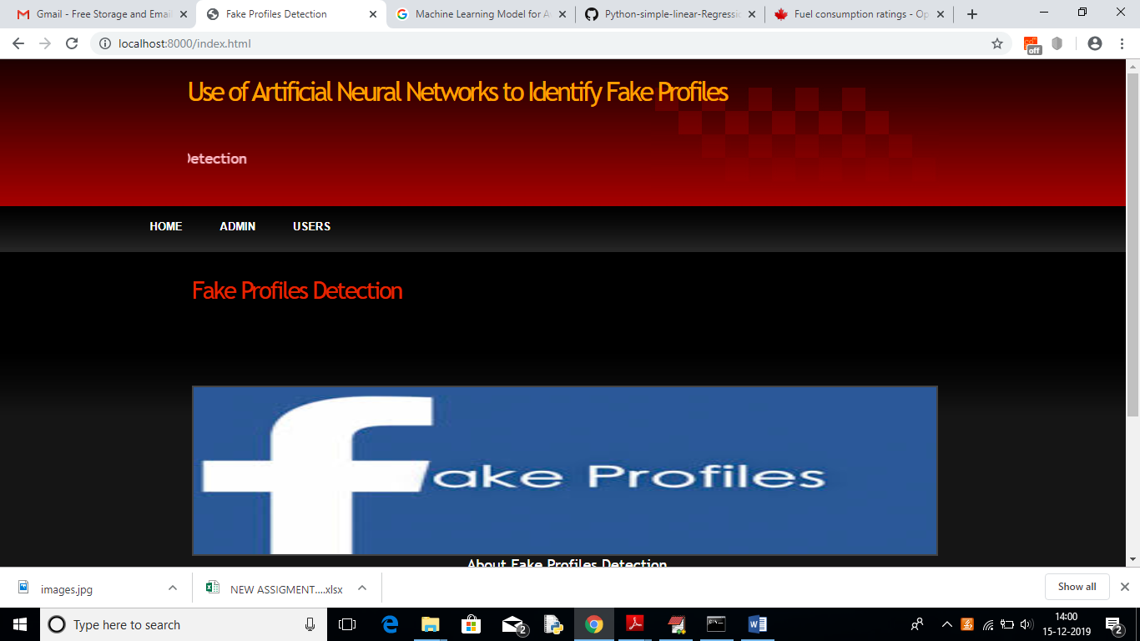

In above screen click on ‘ADMIN’ link to get below login screen

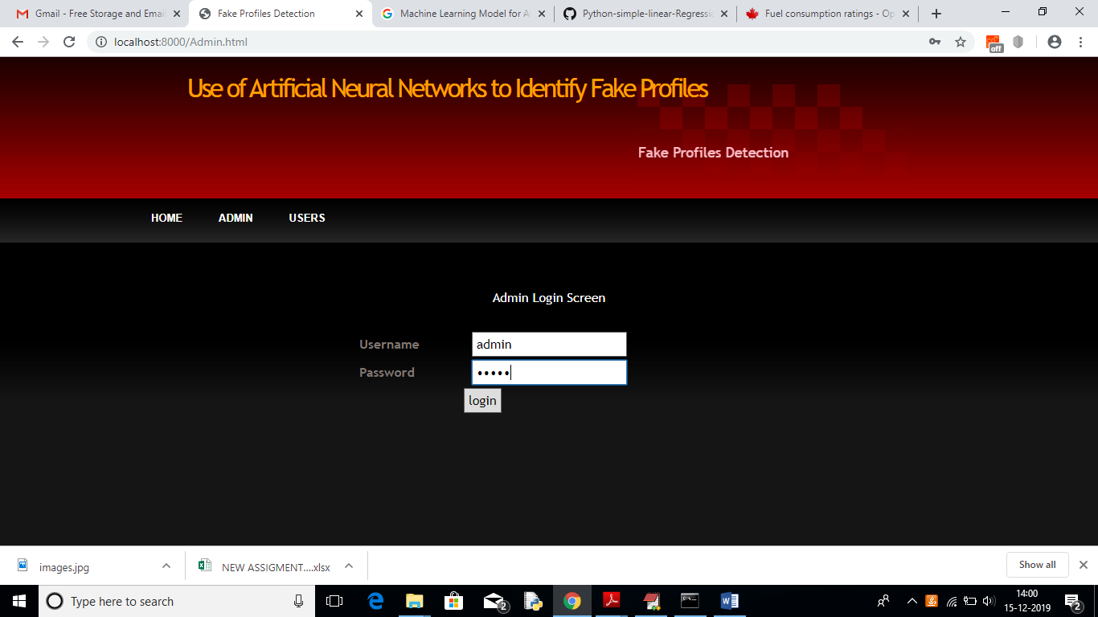

In above screen enter admin and admin as username and password to login as admin. After login will get below screen

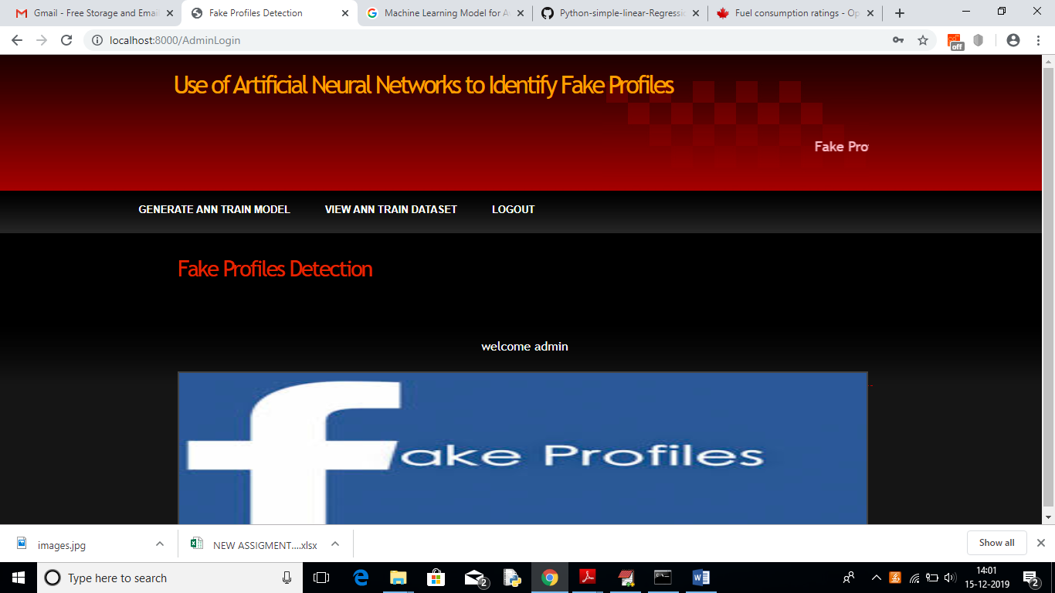

In above screen click on ‘Generate ANN Train Model’ to generate training model on dataset. After clicking on that link you can see server console to check ANN processing details with accuracy

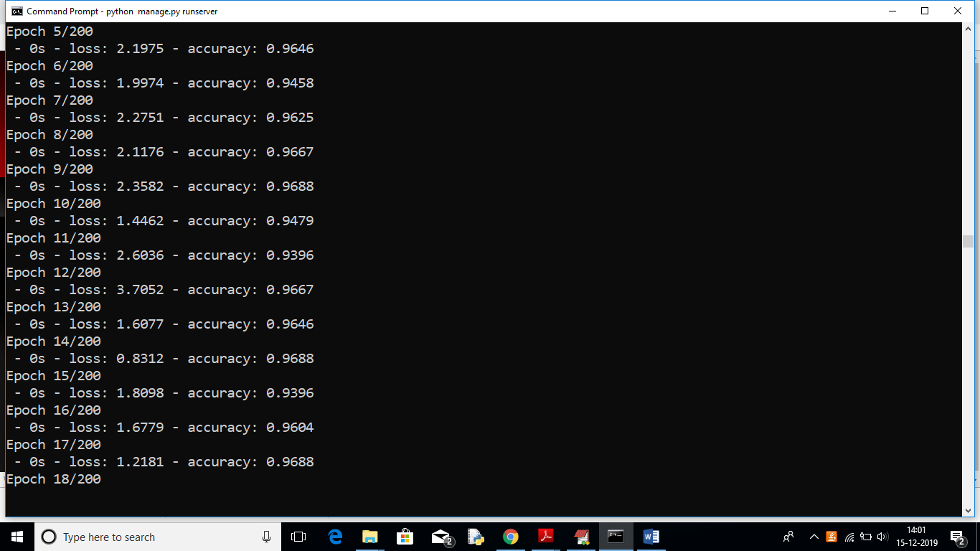

In above black console we can see all ANN details.

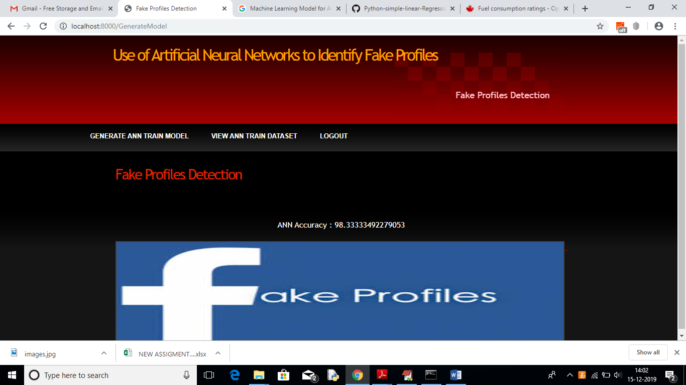

In above screen we can see ANN got 98% accuracy to train all Facebook profile. Now click on ‘View Ann Train Dataset’ link to view all dataset details

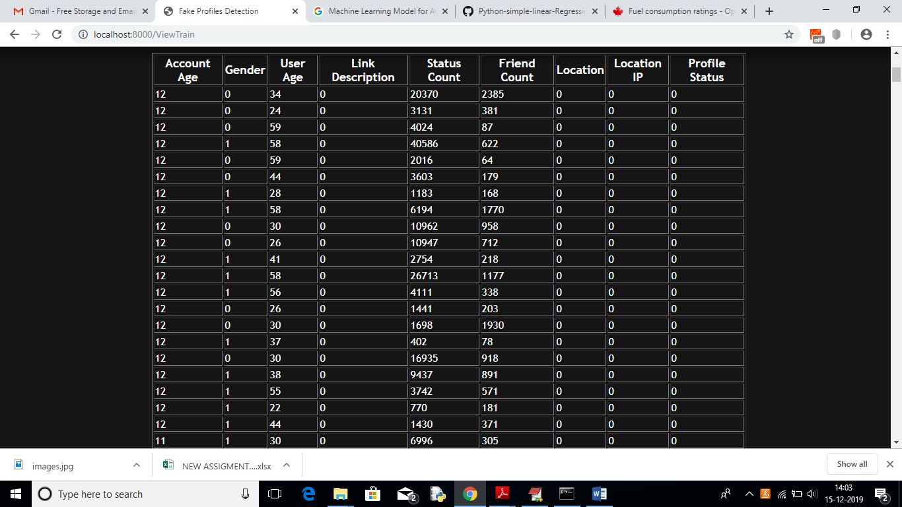

In above screen we can see all train data and scroll down to view all records. Now ANN train model is ready and you can logout and click on ‘User’ link to get below screen.

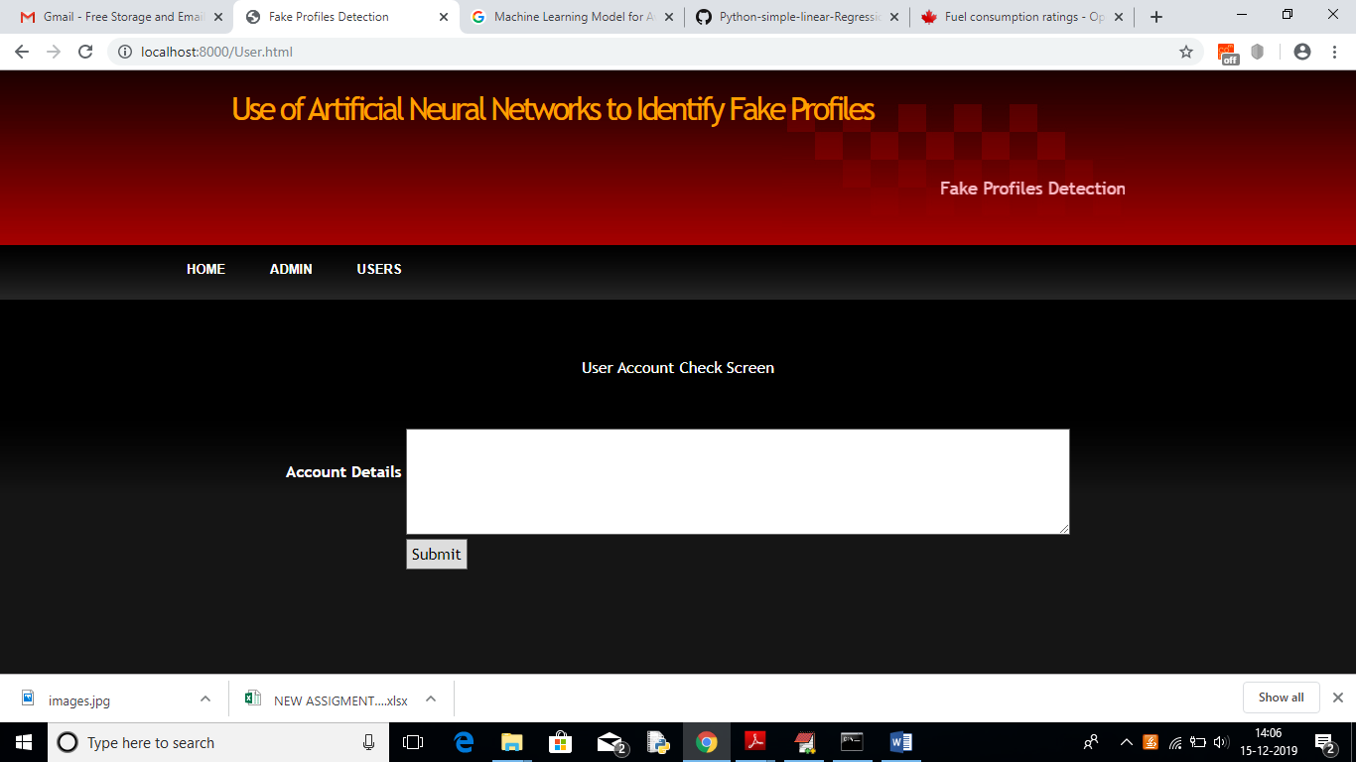

In above screen enter some test account details to get prediction/identification from ANN. You can use below records to check

10, 1, 44, 0, 280, 1273, 0, 0

10, 0, 54, 0, 5237, 241, 0, 0

7, 0, 42, 1, 57, 631, 1, 1

7, 1, 56, 1, 66, 623, 1, 1

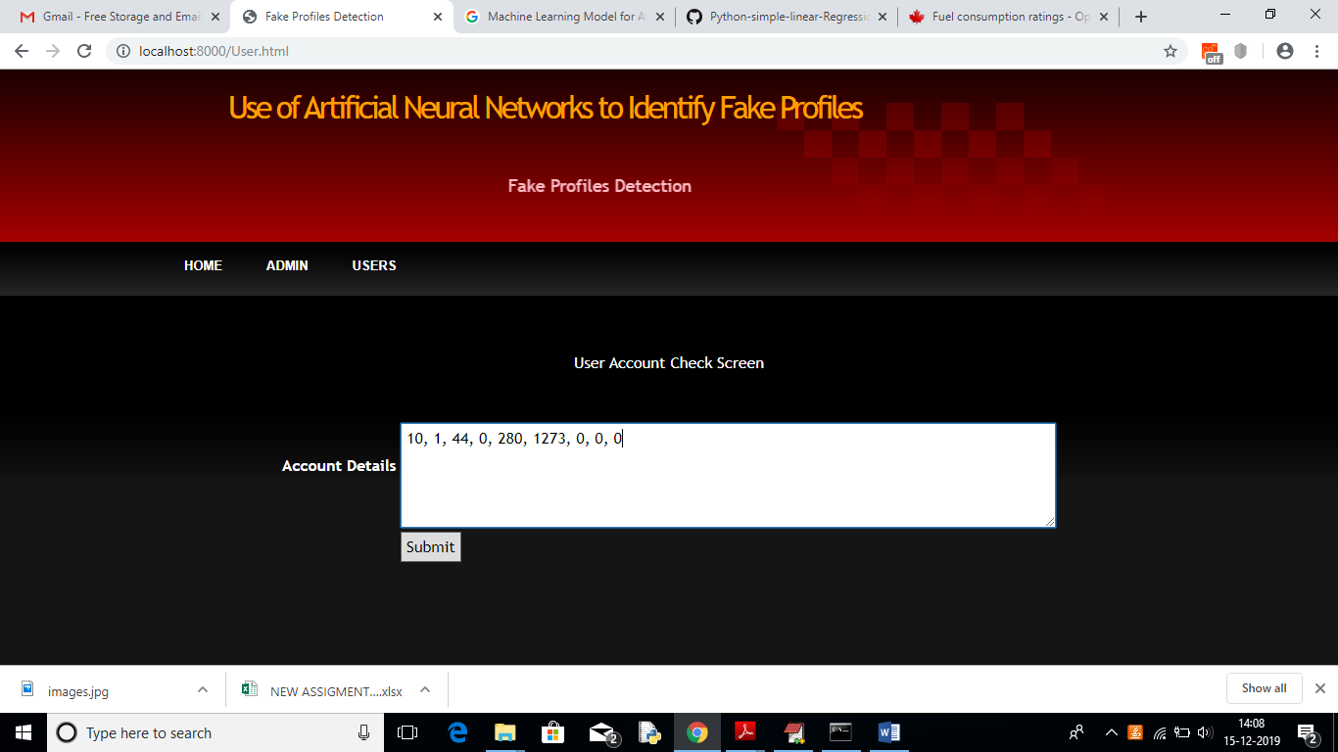

For above input will get below result

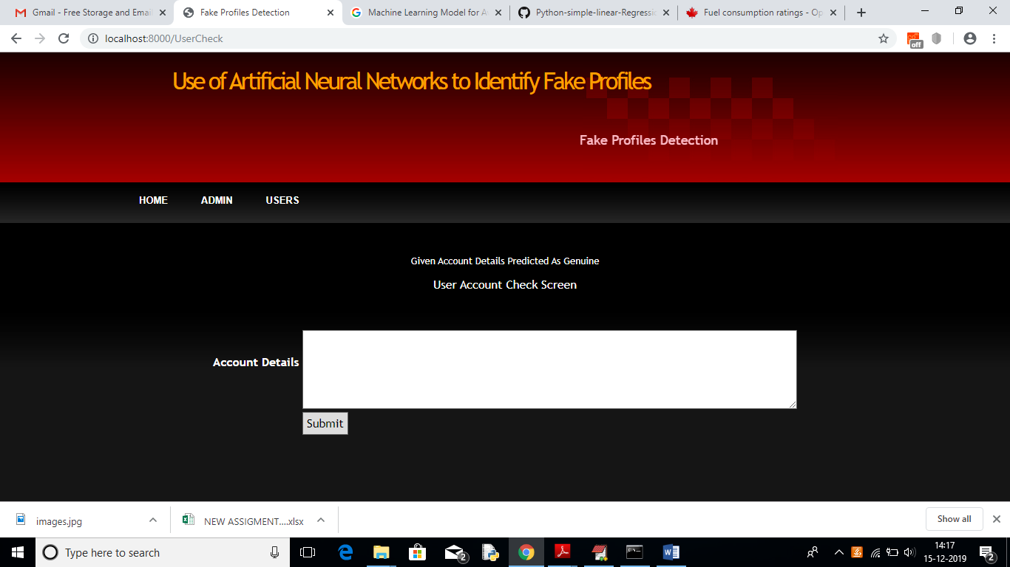

In above screen we can see the result predicted as genuine account

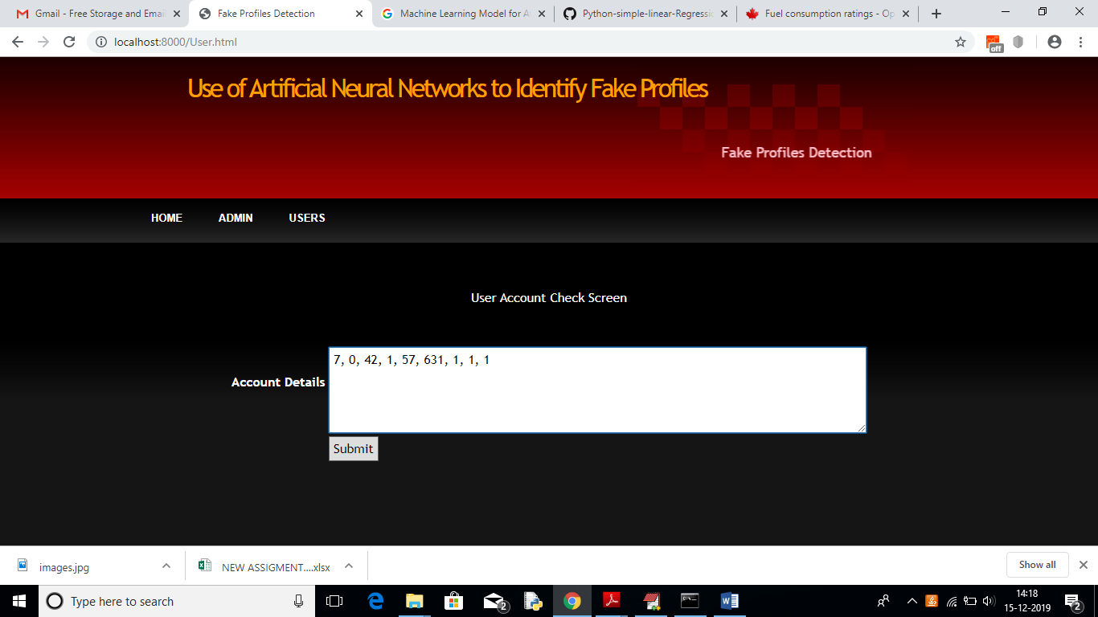

For above account details we got below result

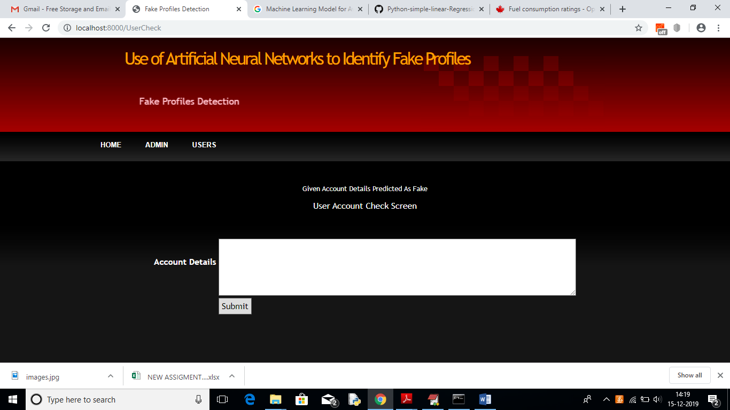

In above screen we got result as fake for given account data

***CHAPTER -6***

***TESTING***

*The chapter shows the various testcases.*

# CHAPTER 6

## SoftwareTesting

Software testing is the process of validating and verifying that a software applicationmeets the technical requirements which are involved in its design and development. It is alsoused to uncover any defects/bugs that exist in the application. It assures the quality of thesoftware. There are many types of testing software viz., manual testing, unit testing, black box testing, performance testing, stress testing, regression testing, white box testing etc. Among theseperformance testing and load testing are the most important one for an android application and nextsections deal with some of thesetypes.

## Black boxTesting

Black box testing treats the software as a "black box"—without any knowledge of internal implementation. Black box testing methods include equivalence partitioning, boundary value analysis, all-pairs testing, fuzz testing, model-based testing, traceability matrix, exploratory testing,and specification-basedtesting.

## White box Testing

White box testing is when the tester has access to the internal data structures and algorithms including the code that implement these.

## PerformanceTesting

Performance testing is executed to determine how fast a system or sub-system performsunder a particular workload. It can also serve to validate and verify other quality attributes of thesystem such as scalability, reliability and resource usage.

## LoadTesting

Load testing is primarily concerned with testing that can continue to operate underspecific load, whether that is large quantities of data or a large number ofusers.

## Manual Testing

Manual Testing is the process of manually testing software for defects. Functionality of this application is manually tested to ensure the correctness. Few examples of test case for Manual Testing are discussed later in this chapter.

|  |  |
| --- | --- |
| **Test Case 1** | |
| Test Case Name | Empty login fields testing |
| Description | In the login screen if the username and password fields are empty |
| Output | Login fails showing an alert box asking to enter username and  password. |

**Table 6:1 Test Case for Empty Login Fields**

**Figure 6-1 Test Case for Empty Login Fields**

|  |  |
| --- | --- |
| **Test Case 2** | |
| Test Case Name | Wrong login fields testing |
| Description | A unique username and password are set by administrator. On entering wrong username or password gives. |
| Output | Login fails showing an alert box username or password  incorrect. |

**Table 6:2 Test Case for Wrong Login Fields**

**Figure 6-2 Test Case for Wrong Login Fields**

|  |  |
| --- | --- |
| **Test Case 3** | |
| Test Case Name | User Signup Fails. |
| Description | User signup need to provide all data. |
| Output | Signup Fails and an alert message appears asking to enter valid email and name. |

**Table 6:3 Test Case for Signup fail**

***CHAPTER -7***

***RESULTS&CHALLENGES***

*The chapter describes the results and challenges faced in theproject.*

# CHAPTER 7

**RESULTS AND CHALLENGES**

## Results

The current android application is developed using Xml, Java, SQL with Firebase connectivity. It can be used by every individual who are in a need of fulfilling their household services.

At the time of submission of my application was capable of doing the following:

* + Displaying thehome screen with differentfragments.
  + Authentication of user by using login screen usingFirebase.
  + Home screen to display based on user or serviceprovider.
  + After successful login of user, they can choose the service and book a slot of their particular service provider from the displayedlist.
  + Add, update, view, delete the userdetails.
  + After successful login of service provider, they can view all the bookings that are booked by the users and can attend them one byone.
  + Service provider can also set his preferences to not available, if he’s too busy or many users had already bookedhim.
  + Service provider has the ability to change their particular radius of location forservicing.
  + He can set up to 10 kmradius.
  + Logout and end the session.

## Challenges

* + - Understanding the connections of SQLite Database is a tricky part and confusing when dealing with multiple tables within adatabase.
    - Making exact orientation API design levels was a difficult task as there are many types of devices like desktop, tablet, mobile with varying screen size andresolutions.
    - Implementing synchronization with Firebasewas a challengingtask.
    - Learning different technologies and frameworks with littleguidance.

***CHAPTER -8***

***CONCLUSIONS & FUTUREWORK***

*The chapter gives brief conclusion about theproject.*

# CHAPTER 8

# CONCLUSION

## Conclusion

## we use machine learning, namely an artificial neural network to determine what are the chances that a friend request is authentic are or not. Each equation at each neuron (node) is put through a Sigmoid function. We use a training data set by Facebook or other social networks. This would allow the presented deep learning algorithm to learn the patterns of bot behavior by back propagation, minimizing the final cost function and adjusting each neuron's weight and bias.

## Scope for futurework

## 

## Each input neuron would be a different, previously chosen feature of each profile converted into a numerical value (e.g., gender as a binary number, female 0 and male 1) and if needed, divided by an arbitrary number (e.g., age is always divided by 100) to minimize one feature having more influence on the result than the other. The neurons represent nodes. Each node would be responsible for exactly one decision-making process

## Limitations

* [1].Brooks,R.E.(1997) ―Towards a theory of the cognitive processes in computer programming,‖ Int. J. Man-Mach. Studies, vol. 9, pp. 737–751.

# BIBLIOGRAPHY

Code snippets for any errors <http://stackoverflow.com/>

Android Development Guide htt[ps://www](http://www.udemy.com/android).[udemy.com/android](http://www.udemy.com/android)

Xml and Layout Guide htt[ps://www](http://www.androidhive.com/).[androidhive.com/](http://www.androidhive.com/)

Connecting to Firebase Docs https://firebase.google.com

Software Testing <http://en.wikipedia.org/wiki/Software_testing>

Manual Testing <http://en.wikipedia.org/wiki/Manual_testing>

Performance Testing <http://en.wikipedia.org/wiki/Software_performance_testing>